REFLEXIO
  - Devansh Gupta, Mengxiang Jiang, Arthur Lanclos, Alan Liang, Brendan Viscomi

High Concept Statement

Kidnapped from his home, a baby koala must fight and outwit his way to freedom from a hostile alien planet. Armed with nothing but a magical umbrella, guide Joey through the strange reflective landscapes of unknown origin...

Features

- Use reflection to form a path to the exit
- Choose your axis of reflection to strategically reposition enemies and objects
- Outsmart your alien captors and return to Earth

Overview

Genre

2D Puzzle Platformer

Competition

And Yet It Moves includes a world-rotation mechanic, but contains no enemies. The levels are purely about making it to the end. Reflexio, however, places more of an emphasis on the action aspect, requiring the user to outwit or battle various enemies.

Rolando is a puzzle platformer in which the user rotates the world to roll balls around the world and get them to the ultimate goal. The primary difference is the use of rotation in Rolando rather than the reflection mechanic in Reflexio. Players reflect across the center, which allows them to pass through walls and past enemies.

Unique Selling Points

Reflection Mechanic: Your primary ability is to reflect the world about an axis. The axis acts as a mirror and all objects, walls, and enemies are converted into their respective counterparts.

Non-Reflectable Objects: The player and some objects in the world remain stationary during a reflection. In these situations, the player must use a different methodology to surpass these obstacles.

Controlled axis of reflection: Select an axis using the mouse or keyboard to determine the location and volume of the reflection; only equal slices of the world will be reflected.

Design Goals

Challenging Puzzles: As the player progresses, more axes of reflection become available and levels become increasingly difficult. These puzzles, involving multiple reflections about different axes, will challenge the intellect of the player.

Fast-Paced: The penalty for failure is small. Falling from great heights does not kill the player, and small level design keeps player frustration to a minimum. If players ever get stuck, they can restart the level at any point.
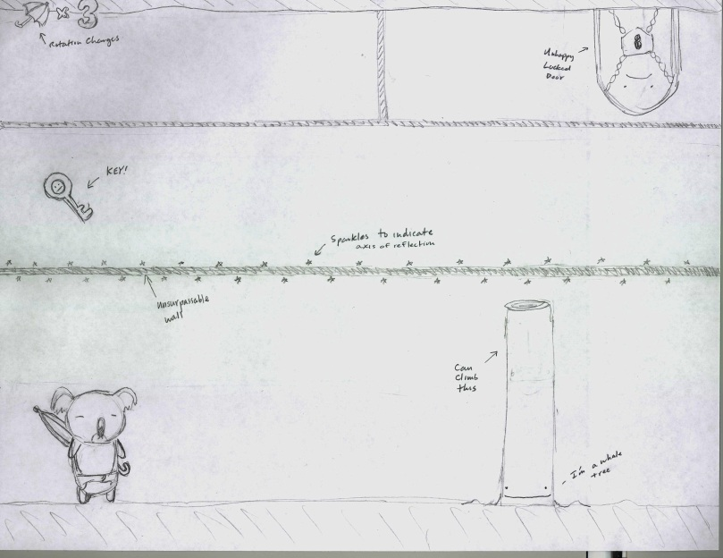

Gameplay Sketch

Shown to the right is a player mode sketch of the game. The shimmering line in the center is the line of reflection, across which the world gets reflected. In the top left is the number of reflection charges remaining in the umbrella. Later in the game, the player chooses the axis of reflection wherever he/she wants.

Additional Details

The player is able to choose the axis of reflection as the game progresses. Although player movement is continuous, the position of the axis is limited to discrete points. If the axis is not in the middle of screen, only a portion of the screen will be reflected. For example, suppose the screen is divided into four rows A, B, C, D and the player is using a horizontal axis of reflection. In the standard case, the axis is between B and C and after reflection, the state of the screen will be D, C, B, A. In the non-standard case, the axis may be between A and B or C and D. After reflection, the state of the screen will be B, A, C, D or A, B, D, C respectively.

